**Contents At Glance**

Page no.

1. Introduction

* Introduction 3
* Why Is The Project 3
* Summary Of The Project 4

2. System Study

* Existing Products Study 6
* Limitation Of Existing System 7
* Proposed System Feature List 7
* Mockups 8
* Feasibility Study 10
* SWOT Analysis 14

3. System Design

* Context Diagram 16
* Data Flow Diagram 18
* Use Case Diagram 21
* Activity Diagram 24
* Class Diagram 26
* ER Diagram 28
* Swimlane Diagram 31
* Class-Responsibility-Collaboration 33
* Sequence Diagram 35
* State Diagram 38

4. Implementation

* Proposed Technology & Screenshots 41

5. Conclusion

* Conclusion 46
* Future Directions 46

6. Reference 47

# Introduction

# Introduction :

In software development there are lots of improvement in the area of Architectural design and principles. The philosophies and implementation details are changing as the people guiding the development of the application. Web services are one such area where architects must lean on their creative side and hope that their solutions are still successful. In this report we will explain an exciting voyage down the road of Web services application. From requirements to use cases, to database design, to component frameworks, to user interfaces, we will cover each and every aspect of system design required to build an application with collaborative Web services. We selected online bookstore web service so that books can be bought from the comfort of home through the Internet.

Leisure Life Bookstore is a virtual store on the Internet where customers can browse the catalog and select books of interest. The selected books may be collected in a shopping cart.

**Why Is The Project :**

We decided to create Leisure Life Bookstore by only thinking about the comfort and benefit of the users. Our Site is for everyone. Specially it is for the students so that they can get books in easily. We wanted to create a site where user can search the particular books they want and order it at a much cheaper rate and we will deliver it to them within a short time span.

* Easy to operate website design and hassle-free shopping.
* They can sell their used books at a beneficial rate.
* They can have lots of variety in one place.
* It also reduces the need of going to a physical store or a book shop which requires time investment as you have to walk through various sections and read the synopsis or the blurb.

**Summary Of The Project :**

Basically the main idea of this project is to buy or sell books to different users. Users can buy or sell books according to ther requirements. We have a used books option/category where users can sell their used books at a good price and other users can purchase it. We have varieties of categories of books on our website so user can buy/sell their choice of books. Payment methods have become easier either online, or via mobile transactions or cash on delivery. Easy registration for users throughout the world.

Pros

-Easy Order

-Cost Effective i.e are cheaper

-Environment Friendly

-Allows home delivery

-More stock and variety of books available

Cons

-Piracy issues

-Copyright issues

-You need to be a registered member of the site

-Shipping can take time

**System Study**

**Existing Products Study :**

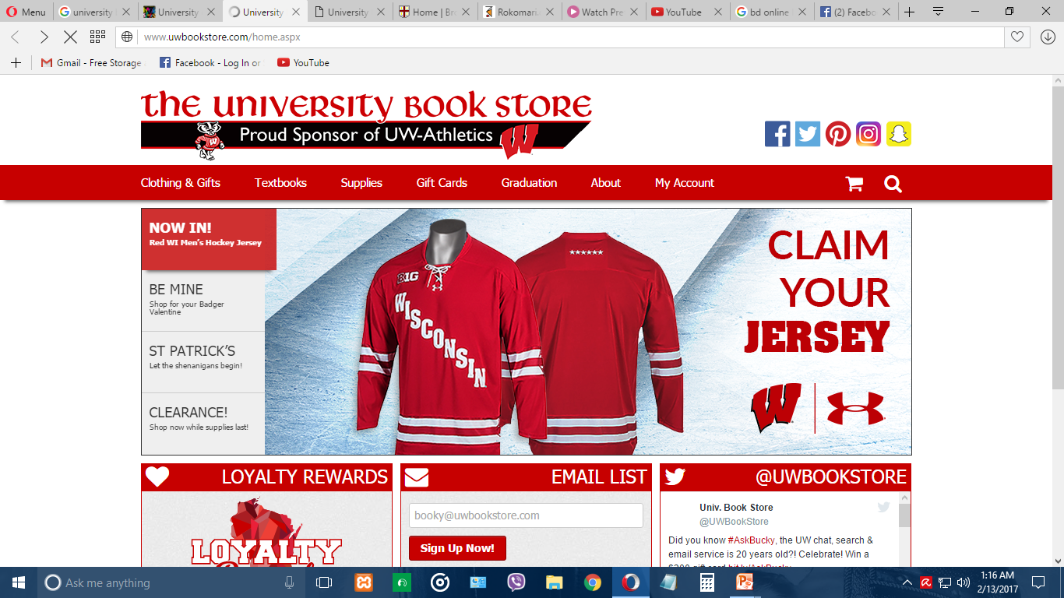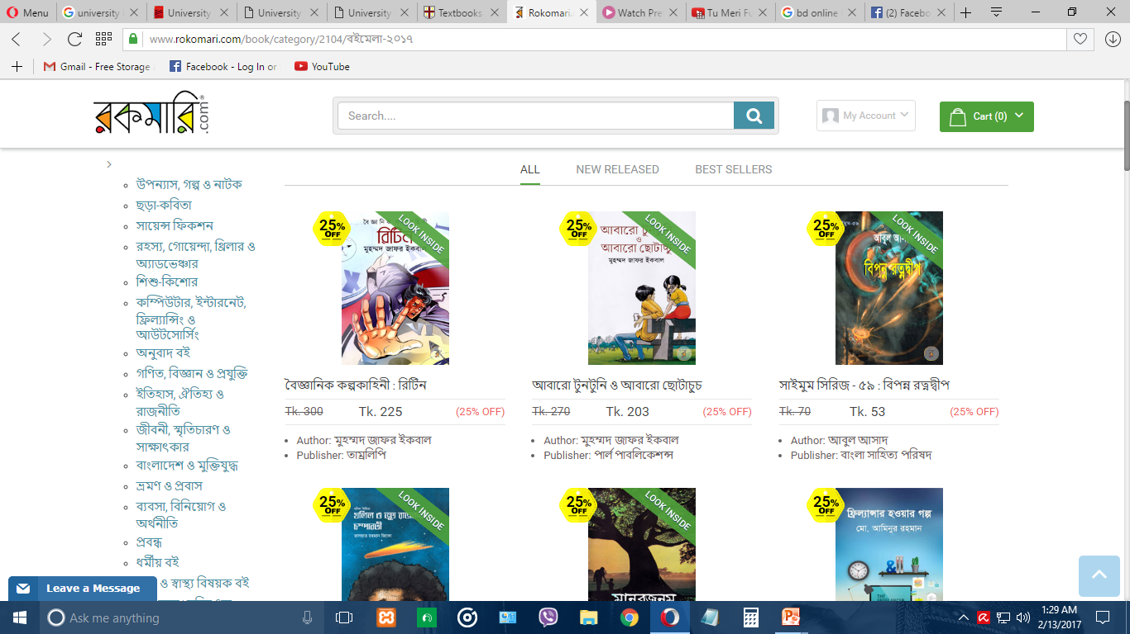

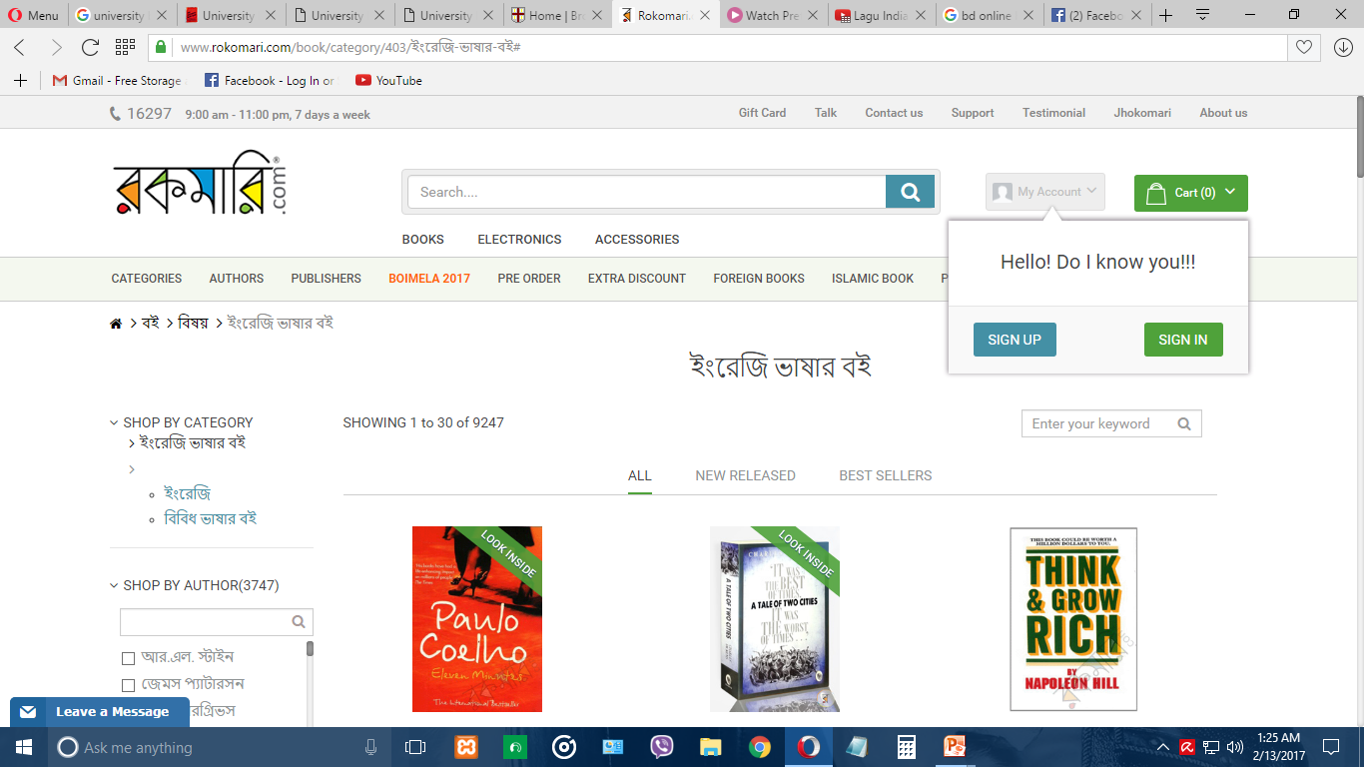

**Limitation Of Existing System :**

There are very few limitations in the existing system. Some of them are –

* Less payment methods.
* Doesn’t allow users to sell their used books.
* Charged very much as shipping fee.
* Doesn’t have textbooks.
* Doesn’t have books as a pdf to download.

**Proposed System Feature List :**

**Modules**

* Home
* On Our Shelves
* Sell Books
* My Account
* Cart
* Checkout
* Contact
* About Us

**Books**

* Text Books
* New Books
* Used Books
* General Books
* Art & Architecture
* Fiction
* Health & Lifestyle
* Science & Nature

**My Account**

* Manage Submission
* Dashboard

**Mockups :**

 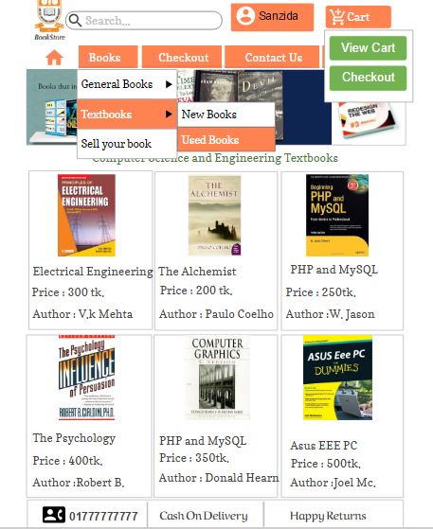

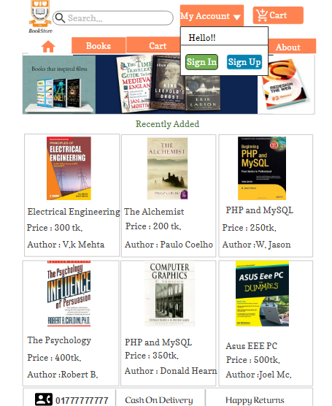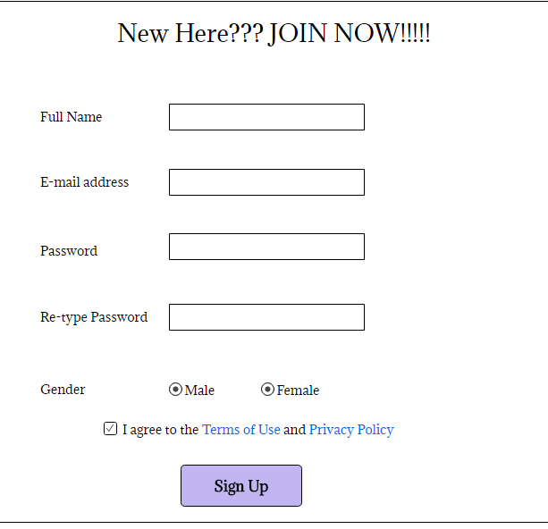

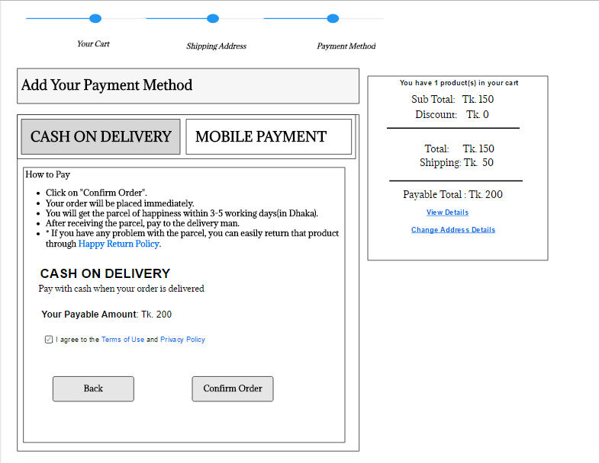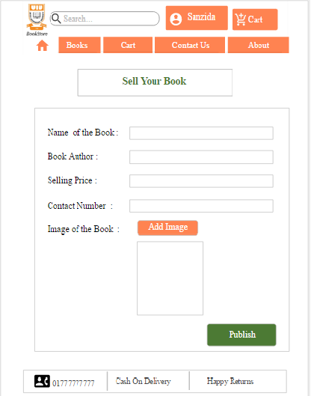

**Feasibility Study:**

A feasibility study is carried out to select the best system that meets performance requirements. To determine what the candidate system is to do by defining its expected performance.

* **Types of Feasibility Study**

a) Economic Feasibility

b) Technical Feasibility

c) Behavioral Feasibility

**Economic** **Feasibility Study :**

* Also known as cost benefit analysis
* To determine the benefits and savings that are expected from a candidate system and compare them with costs.
* If Benefits outweigh Costs, then the decision is made to Design and Implement the system.

**Technical Feasibility Study :**

* It checks whether the existing computer system supports the candidate system or not or up to what extent it supports
* It basically centers around Hardware, Software etc. For e.g. Current Computer is operating at 77 % capacity and running another application can Overload the system so need new system.

**Behavioral Feasibility Study :**

* An estimate should be made of how strong a reaction the user staff is likely to have towards the development of a computerized system.
* It is common knowledge that computer installation have something to do with Turnover, Transfers and changes in employee Job Status. For e.g. SBI Bank.

|  |  |
| --- | --- |
| **BREAK-EVEN ANALYSIS** | |
| Monthly Revenue Break-even | 27,657 |
| Assumptions: |  |
| Average Percent Variable Cost | 25% |
| Estimated Monthly Fixed Cost | 20,615 |

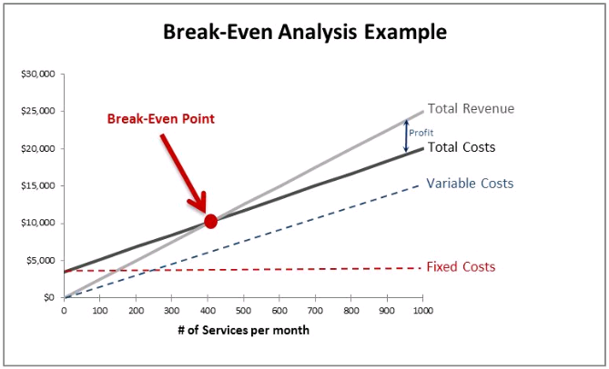

**Projected Profit and Loss :**

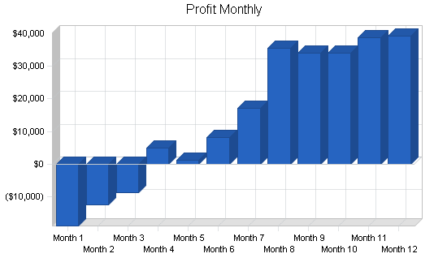

**Profit Yearly:**

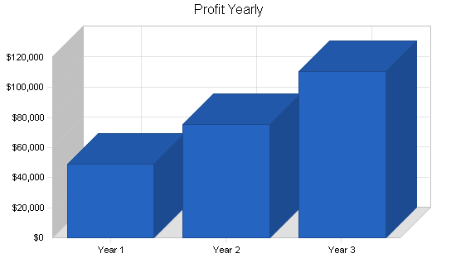

**Cash Flow Analysis:**

* This is the key areas where we will spend our start – up capital;
* The Total Fee for Registering the website – **$200**.
* Legal expenses for obtaining licenses and permits as well as the accounting services (*software, P.O.S machines and other software*) – **$300.**
* Insurance (*general liability, workers’ compensation and property casualty*) coverage at a total premium – **$500.**
* Other start-up expenses including stationery and Desktop and utility deposits – (**$1000**).
* Operational cost for the first 3 months (*salaries of employees, payments of bills et al*) – **$3000**
* Miscellaneous – **$200**
* We would need an estimate of $**5,200** to successfully set up our online book store.

**SWOT Analysis :**

**Strengths :**

* Use of Internet as a Storefront for Books services.
* Customer Convenience.
* Less Investment & fewer workforces for starting the venture.
* Target market.
* Minimum physical assets & less overhead charges on warehouses.
* Cost effectiveness to the customers.
* Post sales service of informing customers about new products & new auctions .

**Weaknesses :**

* Supply of Books out of stock.
* Confined to Assam only.
* Dependent on external delivery services of courier services.
* Need Constant maintenance of website.

**Opportunities :**

* Online Bookstore.
* Just a click away.
* To develop relationship with Publishers to offer exclusive editions..
* Collaborations with public sectors to provide rare & antique books.

**Threats:**

* Local Bookshop vendors.
* Price competition/war.
* Increase in the Transportation costs by the courier company.
* Low consumer confidence to buy using online systems.
* Monopoly in Online business held by some players.

**System Design**

**Context Diagram :**

The Context Diagram shows the system under consideration as a single high-level process and then shows the relationship that the system has with other external entities.

**It has 3 main components :**

* + - * Processes (circle)
      * External Entities (rectangle)
      * Data Flows (curved or straight line with arrowhead indicating flow direction)

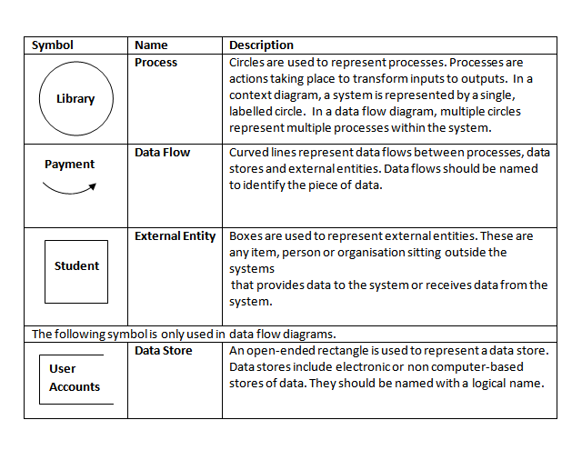

**Rules for Creating a Context Diagram:**

a. Start by placing a single process symbol in the center of the page. The symbol represents the entire information system, and you identify it as process 0.

b. Next, place the external entities around the perimeter of the page, and use data flows to connect the entities to the central process.

c. Do not show any data stores in a context diagram because data stores are internal to the system.

*d. Place the external entities around the central process and label them.*

*e. Create labeled input and output data flows between the external entities and the central system.*

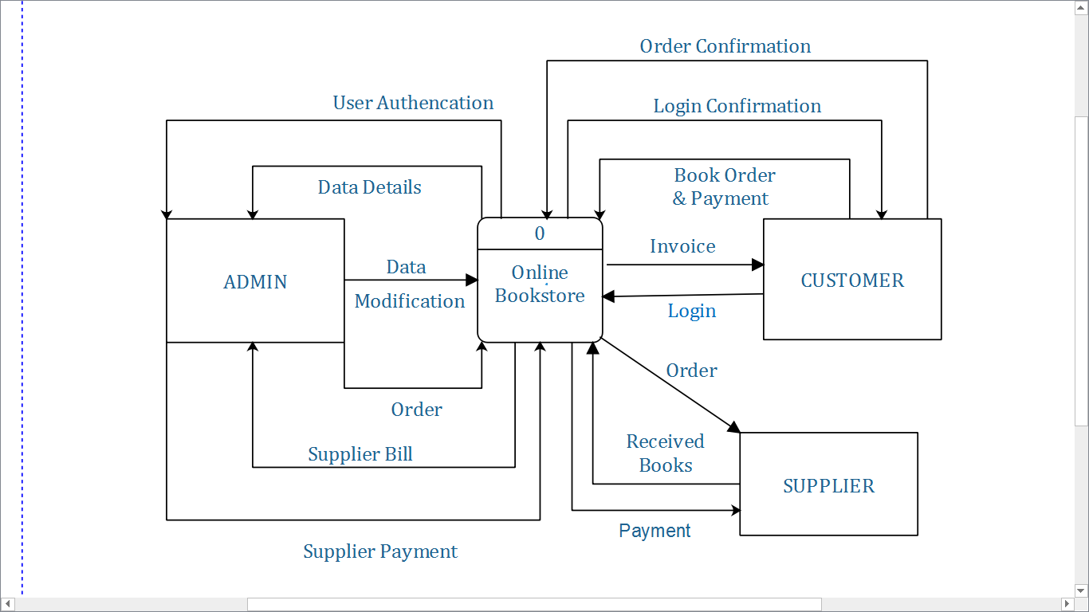

Fig : Context Diagram.

**DATA FLOW DIAGRAM (DFD) :**

A Data-Flow Diagram (DFD) is a graphical visualization of the movement of data through an information system.

**A DFD is process centric and depicts 4 main components.**

* + - * Processes (circle)
      * External Entities (rectangle)
      * Data Stores (two horizontals, parallel lines or sometimes and ellipse)
      * Data Flows (curved or straight line with arrowhead indicating flow direction)

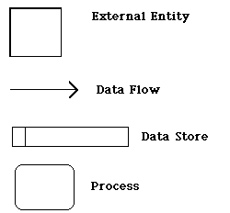

***Functions of each component:***

* **Process:** An activity or function performed for a specific business reason.
* **Data flow:** A single piece of data or a logical collection of data. Always starts or ends at a process
* **Data store:** A collection of data that is stored in some way. Data flowing out is retrieved from the data store. Data flowing in updates or is added to the data store
* **External entity:** A person, organization, or system that is external to the system but interacts with it.

**Rules of DFD:**

* Each process must have a minimum of one data flow going into it and one data flow leaving it.
* Each data store must have at least one data flow going into it and one data flow leaving it.
* A data flow out of a process should have some relevance to one or more of the data flows into a process.
* Data stored in a system must go through a process.
* Filing systems within an organisation cannot logically communicate with one another unless there is a process involved.
* All processes in DFD must be linked to either another process or a data store.

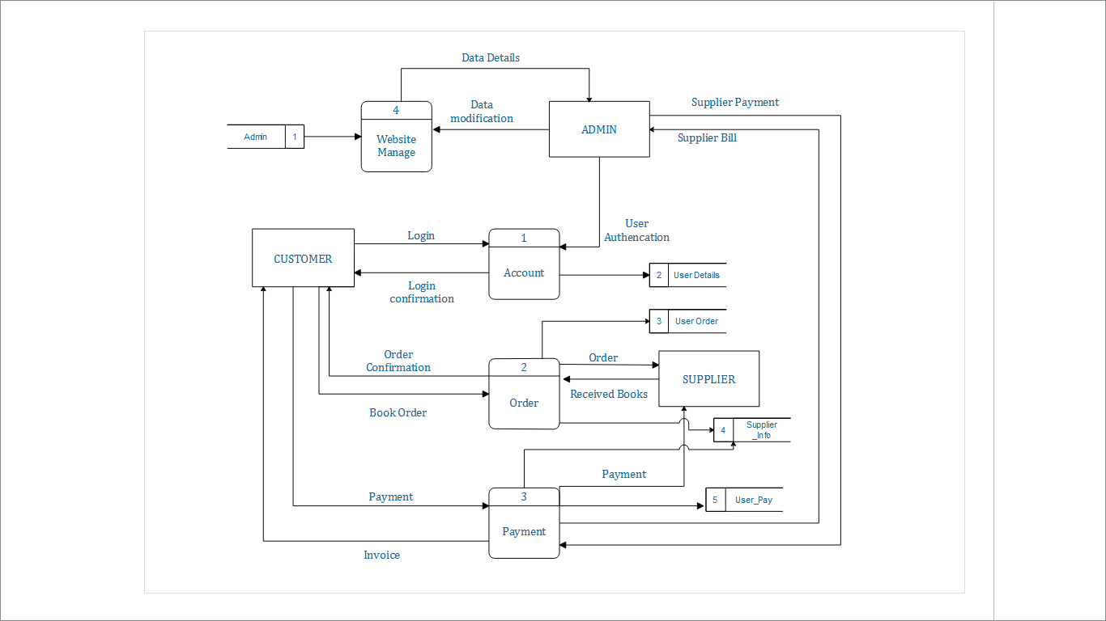

Fig : Data Flow Diagram.

**Use Case Diagram :**

Use case diagrams describe what a system does from the standpoint of an external observer. Or A use case diagram is a collection of actors, use cases, and their communications. The emphasis is on what a system does rather than how.

Use case diagrams are closely connected to scenarios. A **scenario** is an example of what happens when someone interacts with the system.

***The Symbols are:***

***Use Case Actor Communications***

**

A **use case** is a summary of scenarios for a single task or goal. Use cases are ovals.

An **actor** is who or what initiates the events involved in that task. Actors are simply roles that people or objects play. Actors are stick figures.

Communications are lines that link actors to use cases.

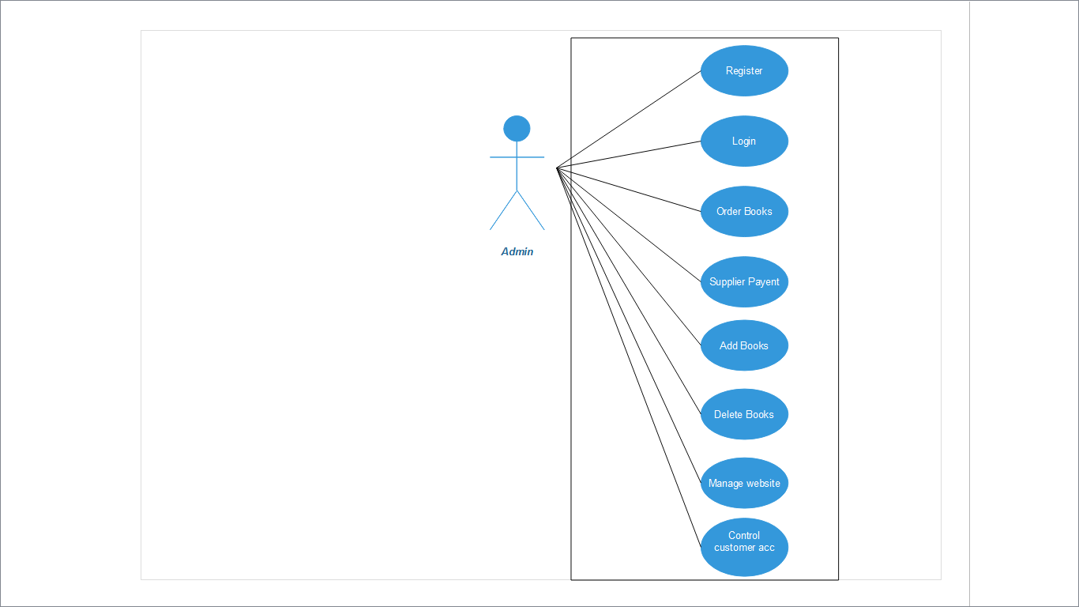

Fig : Admin Use Case Diagram.

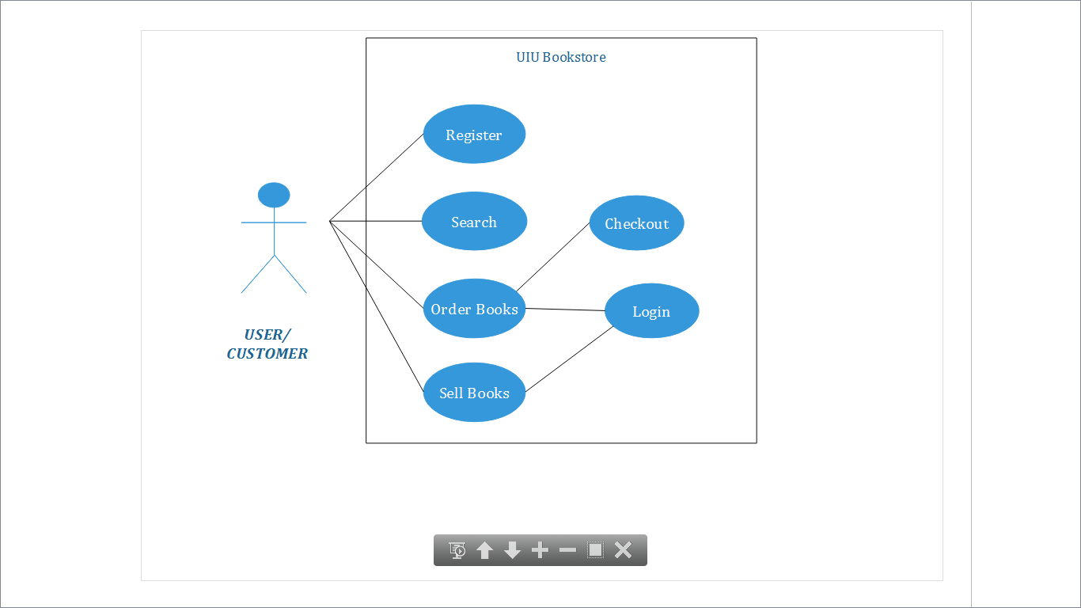

Fig : User Use Case Diagram.

**Activity Diagram :**

Activity Diagram Represent the business and operational workflow of a system. It shows activity, and event that causes object to be in particular state

**Activity Diagram Symbols :**

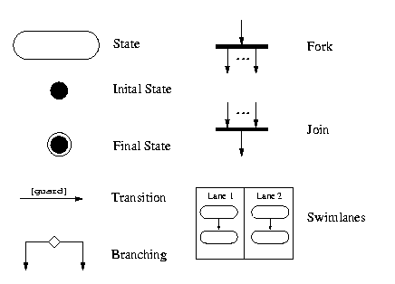

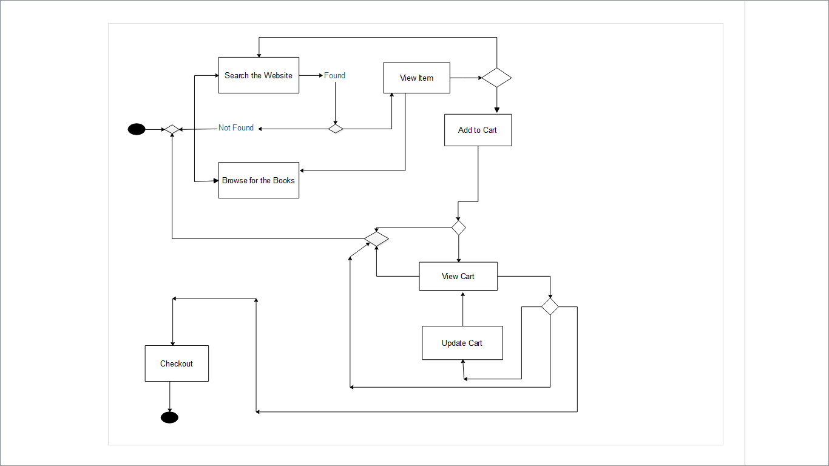

Fig : Activity Diagram .

**Class Diagram :**

A class diagram in the Unified Modeling Language (UML) is a type of static structure diagram that describes the structure of a system by showing the system's [classes](https://en.wikipedia.org/wiki/Class_(computer_science)), their attributes, operations (or methods), and the relationships among objects.

**Class Diagram rules :**

* The name of the class diagram should be meaningful to describe the aspect of the system.
* Each element and their relationships should be identified in advance.
* Responsibility (attributes and methods) of each class should be clearly identified.
* For each class minimum number of properties should be specified. Because unnecessary properties will make the diagram complicated.
* Use notes when ever required to describe some aspect of the diagram. Because at the end of the drawing it should be understandable to the developer/coder.
* Finally, before making the final version, the diagram should be drawn on plain paper and rework as many times as possible to make it correct.

**Class Diagram Symbols :**

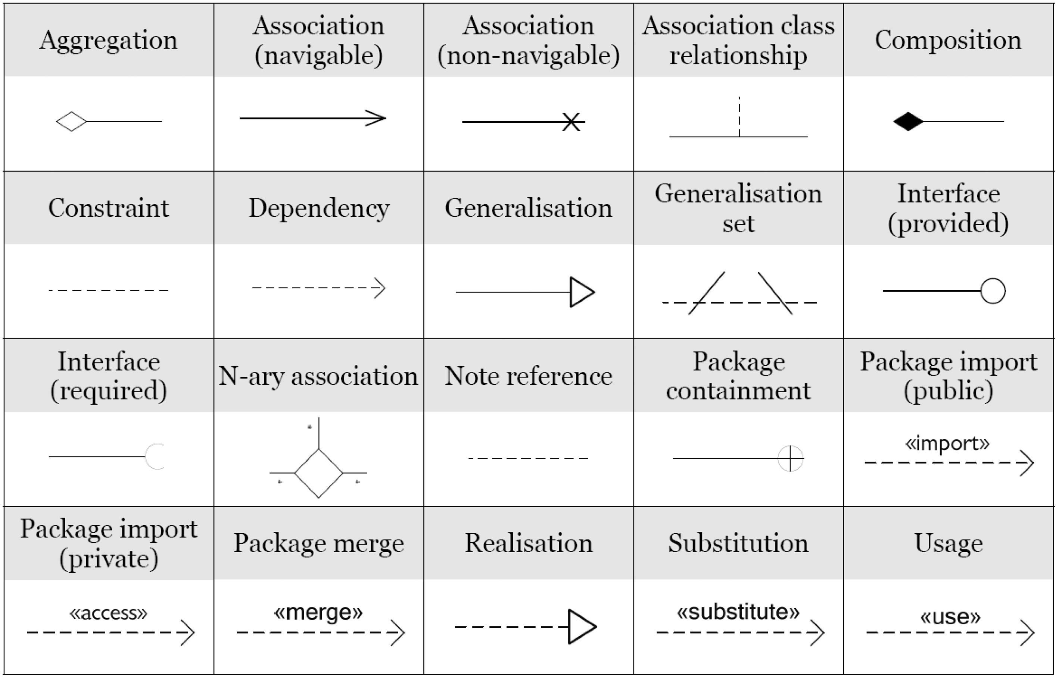

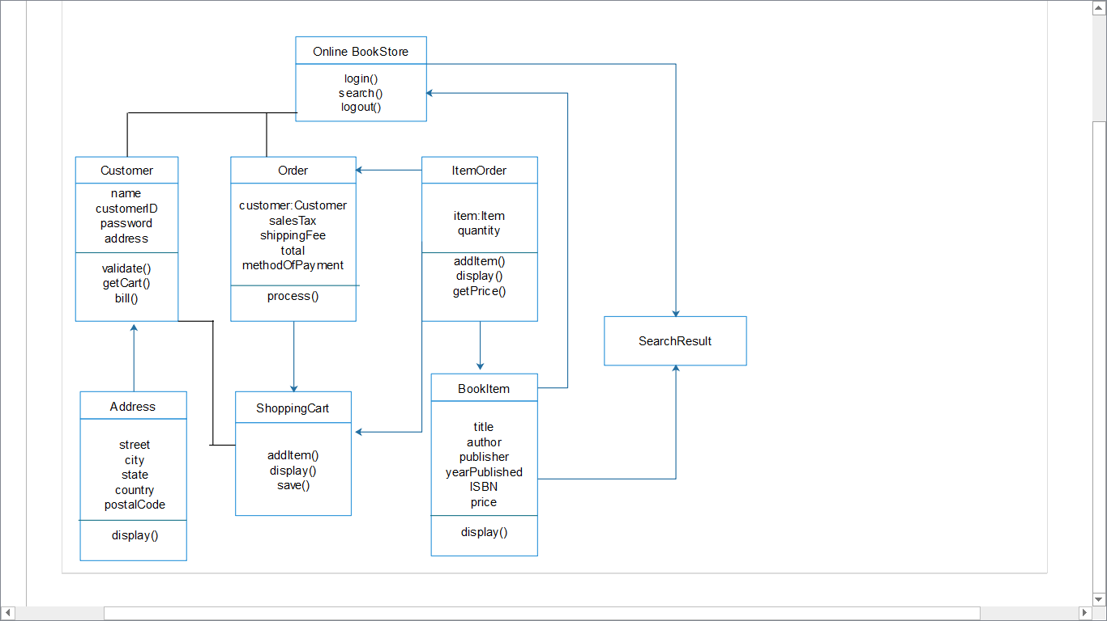Fig : Class Diagram .

**ER Diagram :**

An entity relationship diagram (ERD) shows the relationships of entity sets stored in a database. An entity in this context is a component of data. In other words, ER diagrams illustrate the logical structure of databases.

**ER Diagram Rules**

* Identify the entities : The first step in making an ERD is to identify all of the entities you will use. Draw a rectangle for each entity you can think of on your page. Keep them spaced out a bit.
* Identify relationships :  Look at two entities, are they related? If so draw a solid line connecting the two entities.
* Describe the relationship : How are the entities related? Draw an action diamond between the two entities on the line you just added.
* Add attributes. : Any key attributes of entities should be added using oval-shaped symbols.
* Complete the diagram : Continue to connect the entities with lines, and adding diamonds to describe each relationship until all relationships have been described.

**ER Diagram Symbols :**

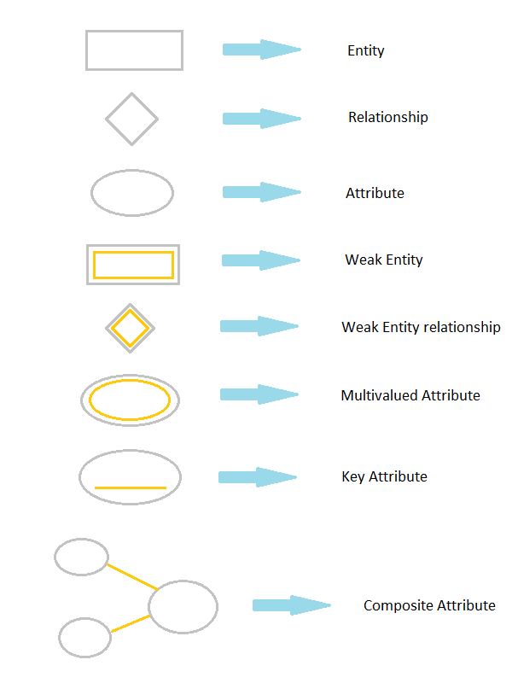

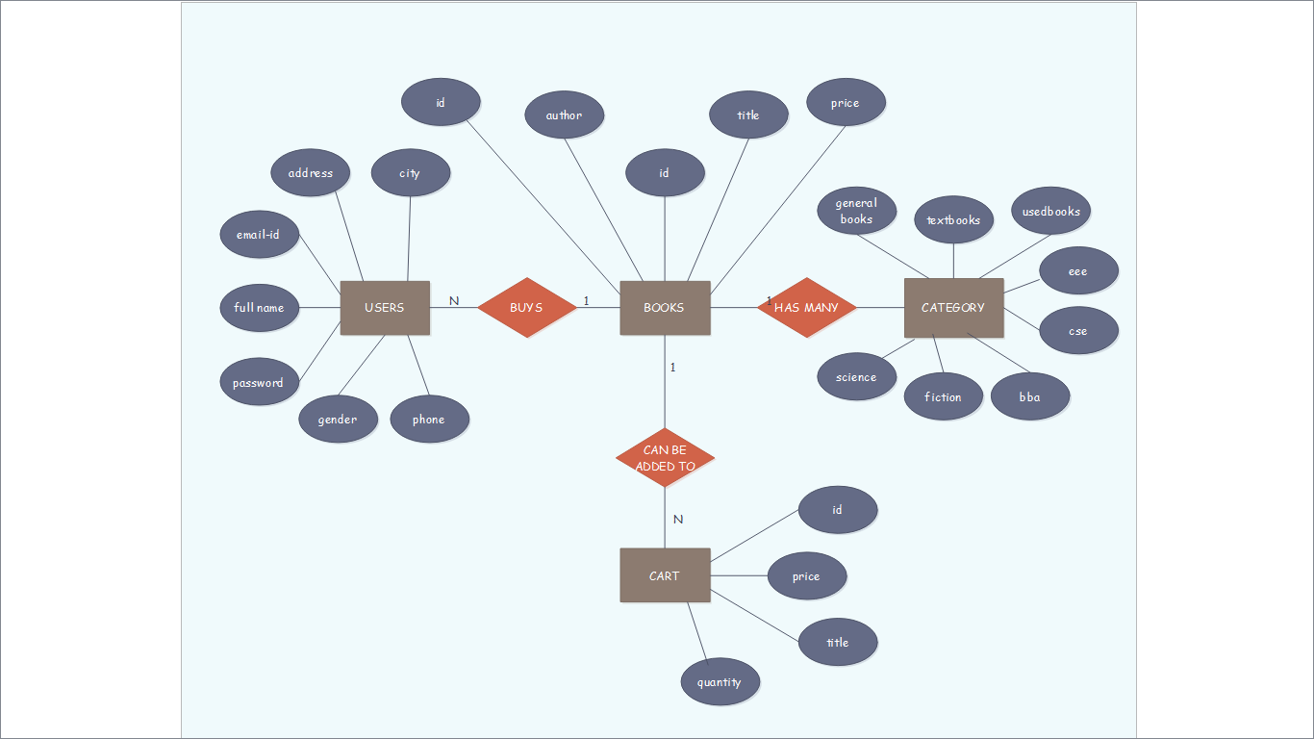

**Swimlane Diagram :**

A swim lane (or swimlane diagram) is a visual element used in process flow diagrams, or flowcharts, that visually distinguishes job sharing and responsibilities for sub-processes of a business process. Swim lanes may be arranged either horizontally or vertically.

**Swimlane Diagram Rules :**

* **Construction** - A swimlane diagram incorporates standard symbols to display information .Each time a new actor is identified, a new column or row should be added. A circle signifies the starting and ending of an event in the process (also known as initial state and final state).
  + A rectangle (in BPMN or UML diagrams, these may be rounded)[8] represents an activity in the process.
  + A diamond represents a decision that must be made.
  + Arrows indicate the flow of the process.
  + A cylinder represents stored data.
* **Verbiage**–
  + Initial state and final state (circles) should state what is being performed.[9]
  + The name of the action (rectangle) should describe its purpose. In activity diagrams, these generally should start with a verb.

**Swimlane Components :**

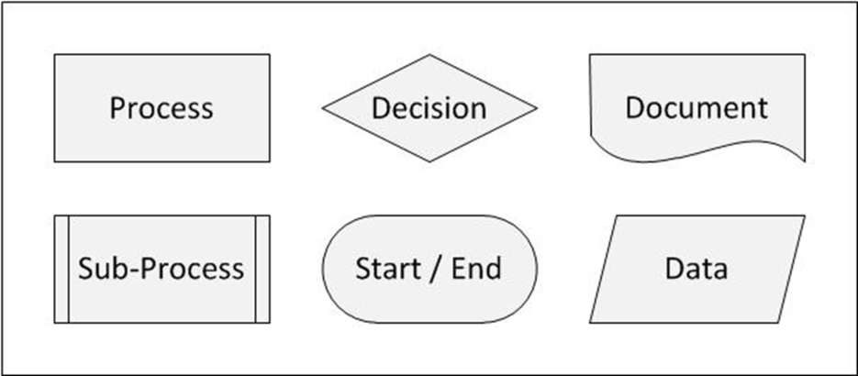

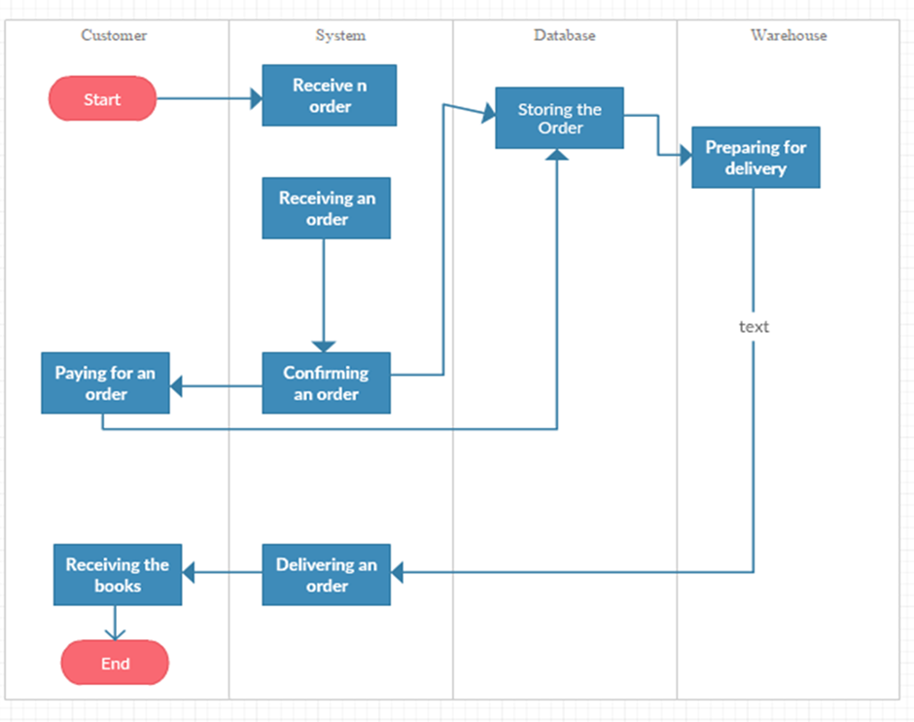

Fig : Swimlane Diagram

**Class-Responsibility-Collaboration(CRC) :**

CRC cards are usually created from index cards. Members of a brainstorming session will write up one CRC card for each relevant class/object of their design. The card is partitioned into three areas:

* On top of the card, the **class** name
* On the left, the **responsibilities** of the class
* On the right, **collaborators** (other classes) with which this class interacts to fulfill its responsibilities.

**CRC Rules :**

* **Find classes**. Finding classes is fundamentally an analysis task because it deals with identifying the building blocks for your application.
* **Find responsibilities**. You should ask yourself what a class does as well as what information you wish to maintain about it. You will often identify a responsibility for a class to fulfill a collaboration with another class.
* **Define collaborators**. A class often does not have sufficient information to fulfill its responsibilities. Therefore, it must collaborate (work) with other classes to get the job done.
* **Move the cards around**. To improve everyone's understanding of the system, the cards should be placed on the table in an intelligent manner.
* **CRC Components :**

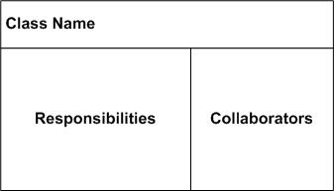

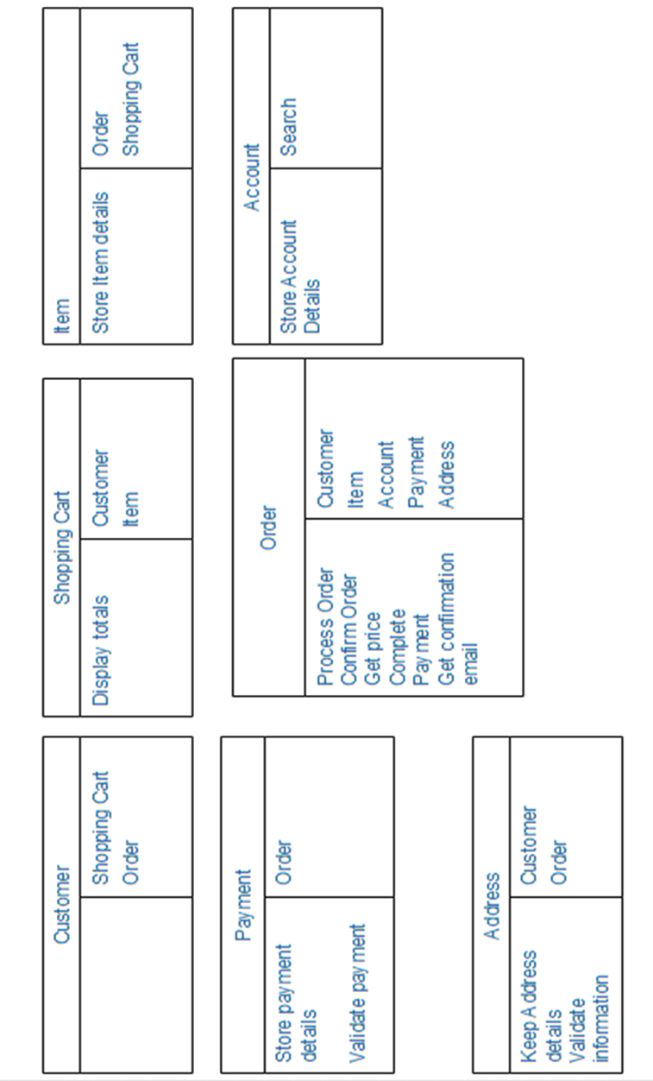

**Sequence Diagram :**

A sequence diagram is a good way to visualize and validate various runtime scenarios. These can help to predict how a system will behave and to discover responsibilities a class may need to have in the process of modeling a new system.

**Sequence Diagram Components :**

* **Class Roles or Participants**  
  Class roles describe the way an object will behave in context.

Object symbol - Sequence diagram

* **Activation or Execution Occurrence**  
  Activation boxes represent the time an object needs to complete a task.

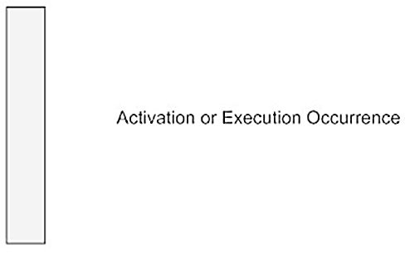

* Messages   
  Messages are arrows that represent communication between object .

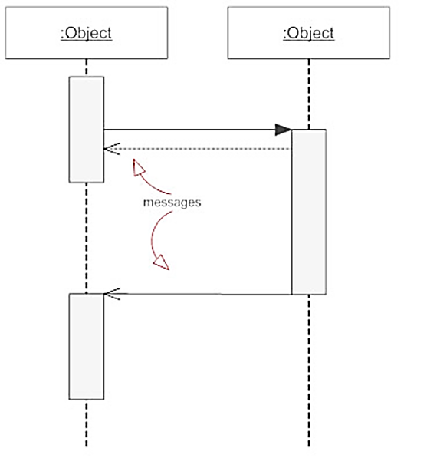

* **Lifelines**  
  Lifelines are vertical dashed lines that indicate the object's presence over time.

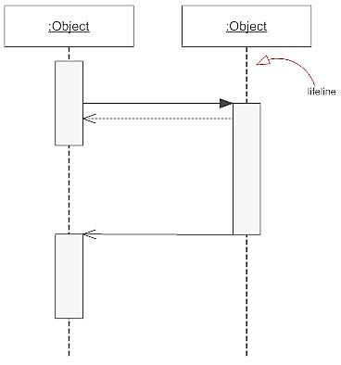

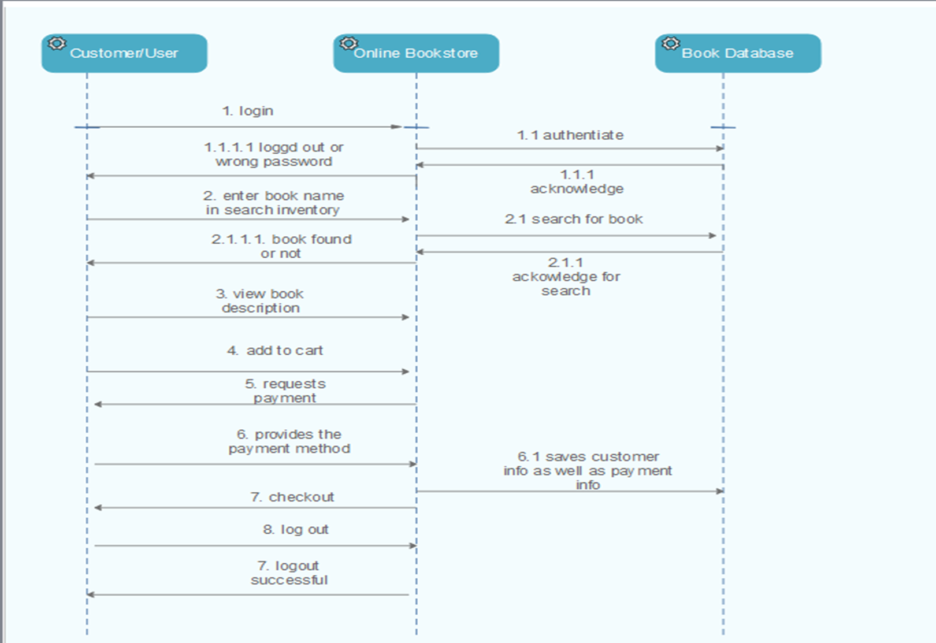

**State Diagram :**

A state diagram is a type of diagram which describes the behavior of systems. State diagrams are used to give an abstract description of the behavior of a system. This behavior is analyzed and represented as a series of events that can occur in one or more possible states.

**State Symbols :**

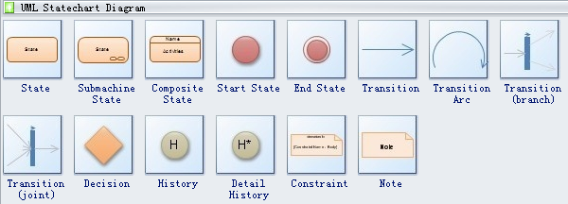

**Symbol Description :**

* **State** defines current condition of an event or activity. 
* **Start state** symbol signals the first step of a process.



* **End state** symbol stands for the result of a process.

Transition

* **Transition** takes operation from one state to another and represents the response to a particular event. 

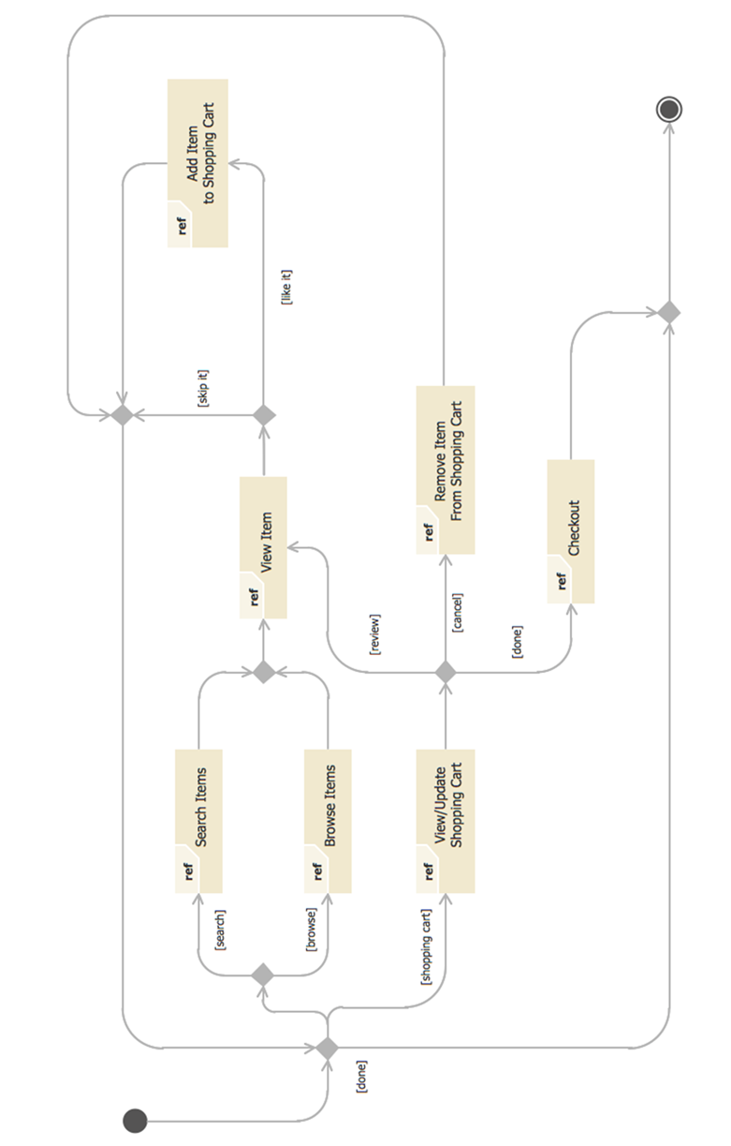

**Implementation**

**Proposed Technology & Screenshots :**

* For mockups of the website we use : <https://moqups.com>
* For drawing diagrams we use : Edraw Max

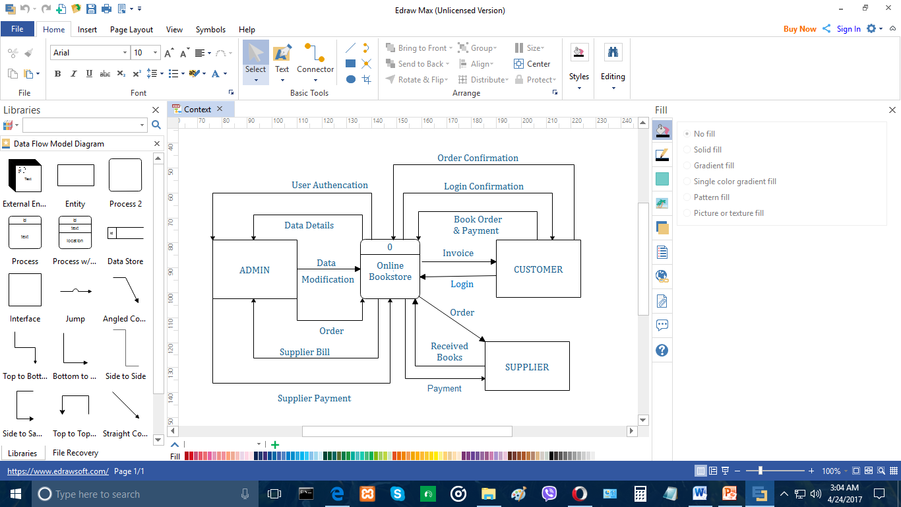

* For the project management tool we use : Orangescrum

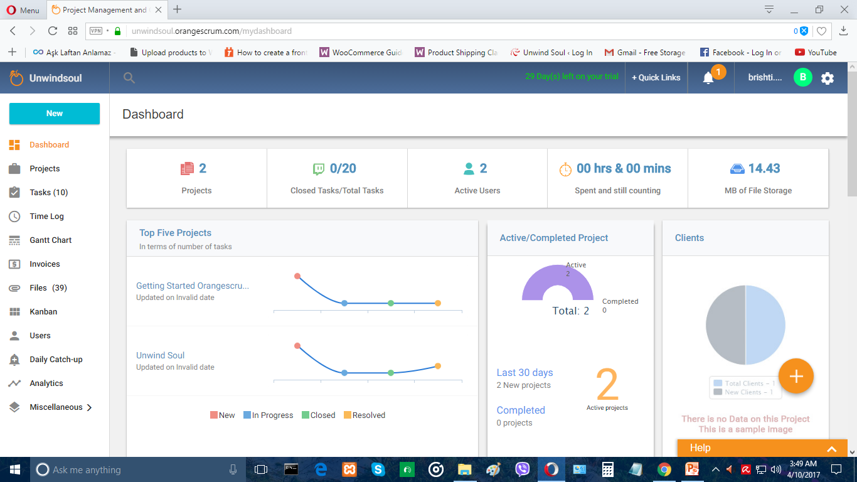

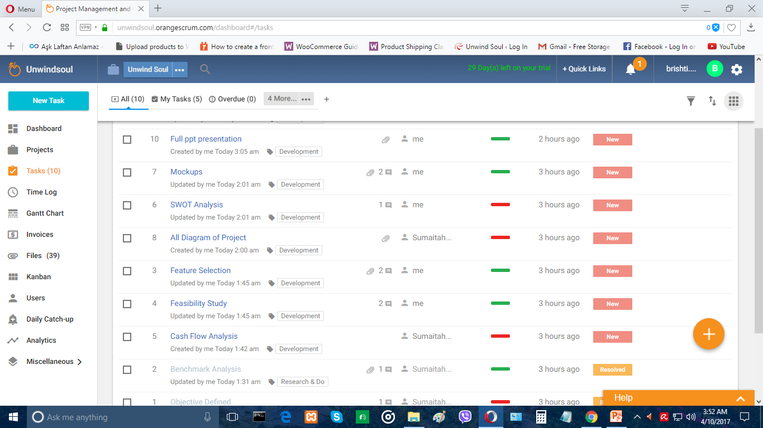

**To create the website we work with :**

* Wordpress 4.7.4
* Woocommerce plugin
* Themes
* HTML & CSS

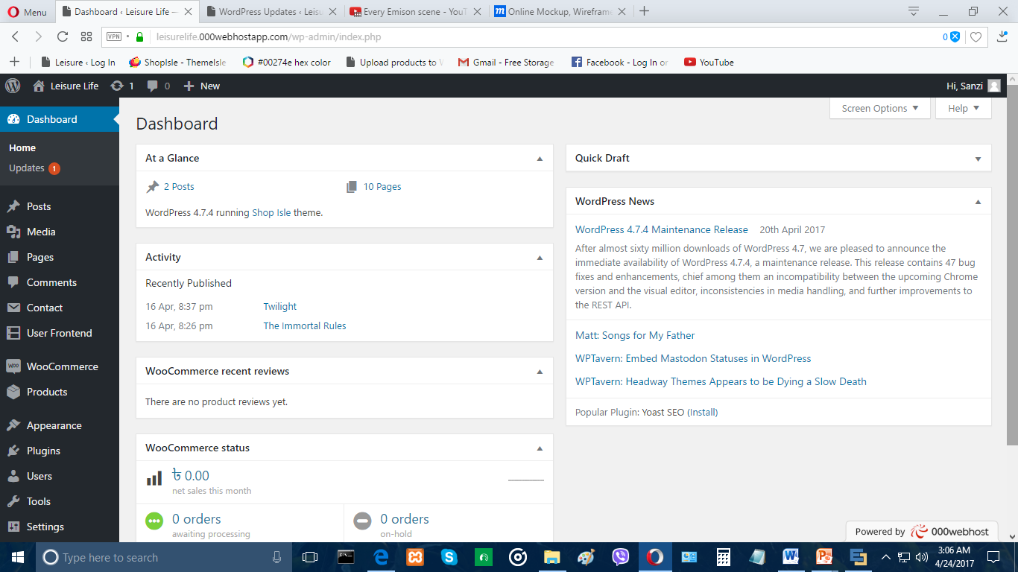

**Some screenshots of the website :**



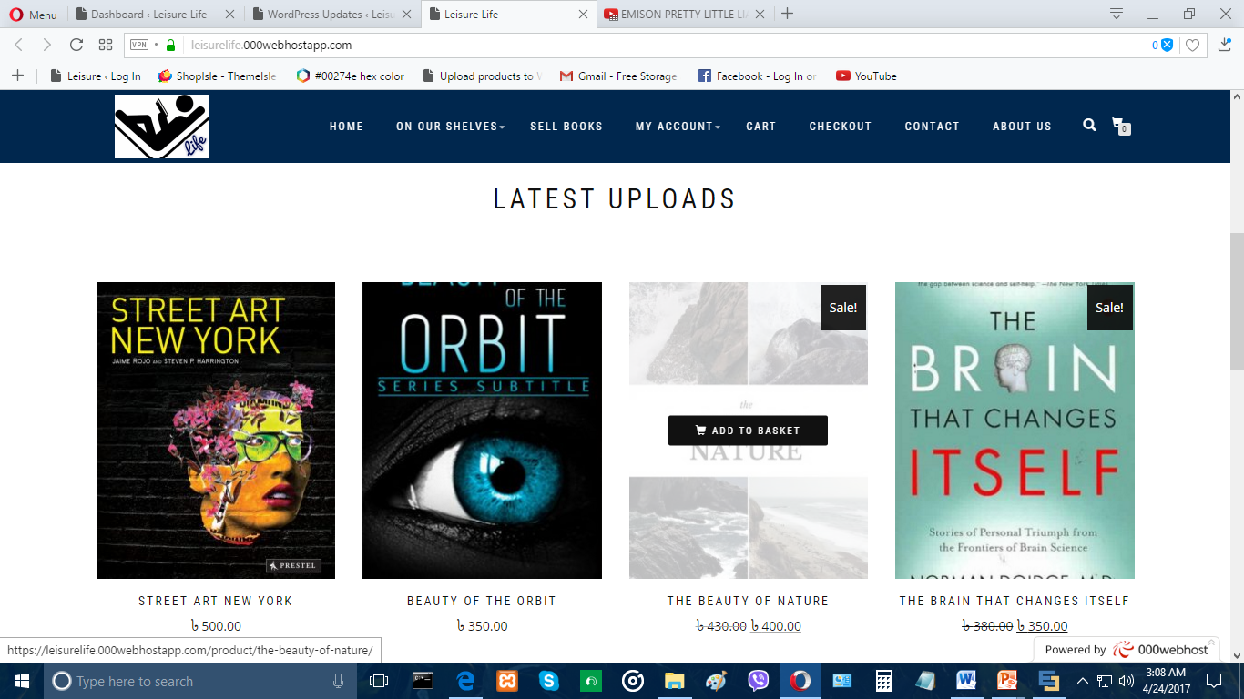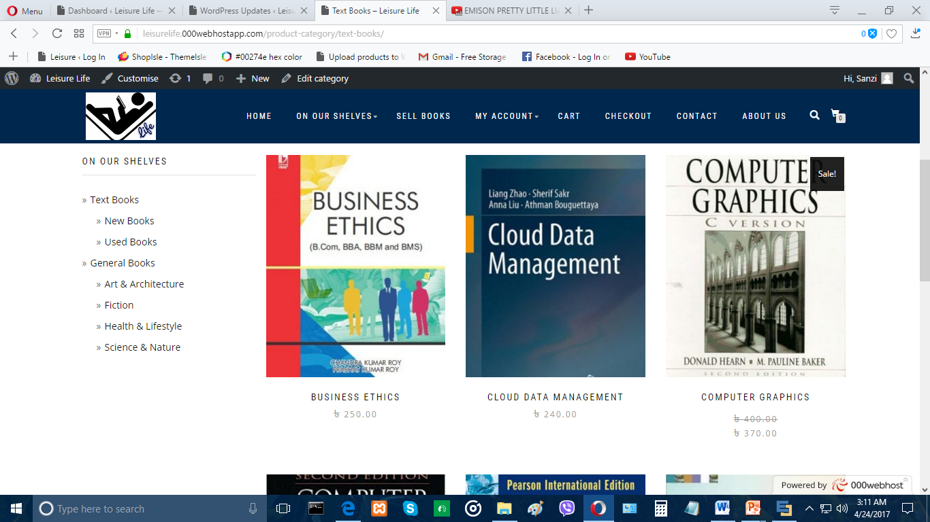

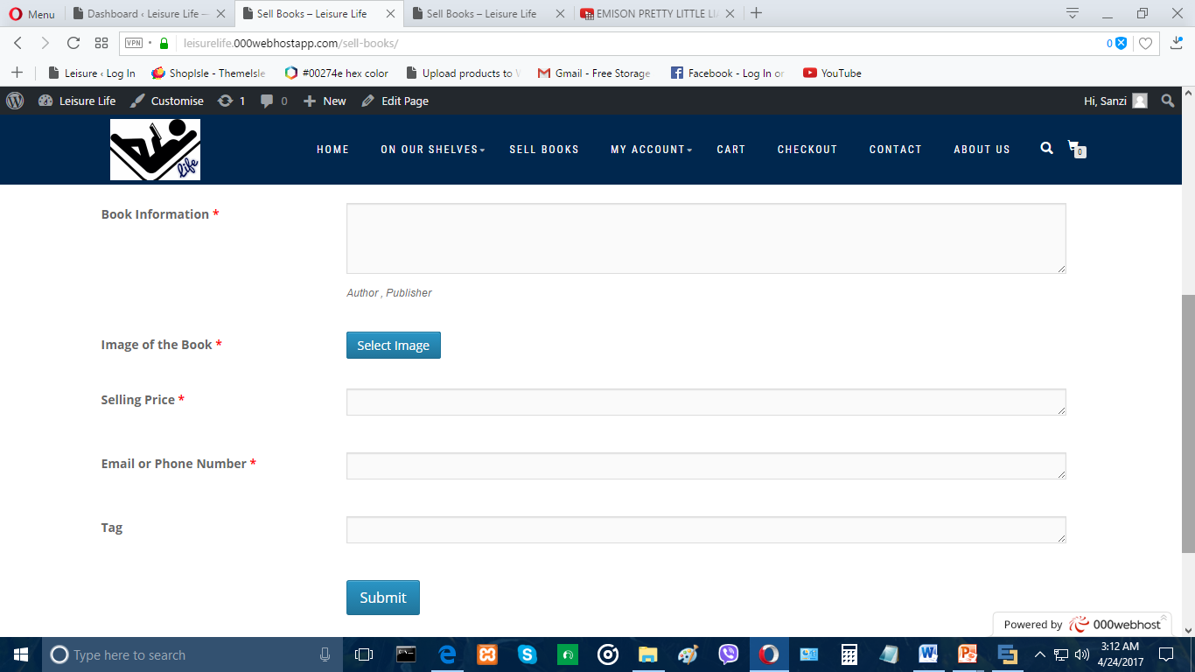

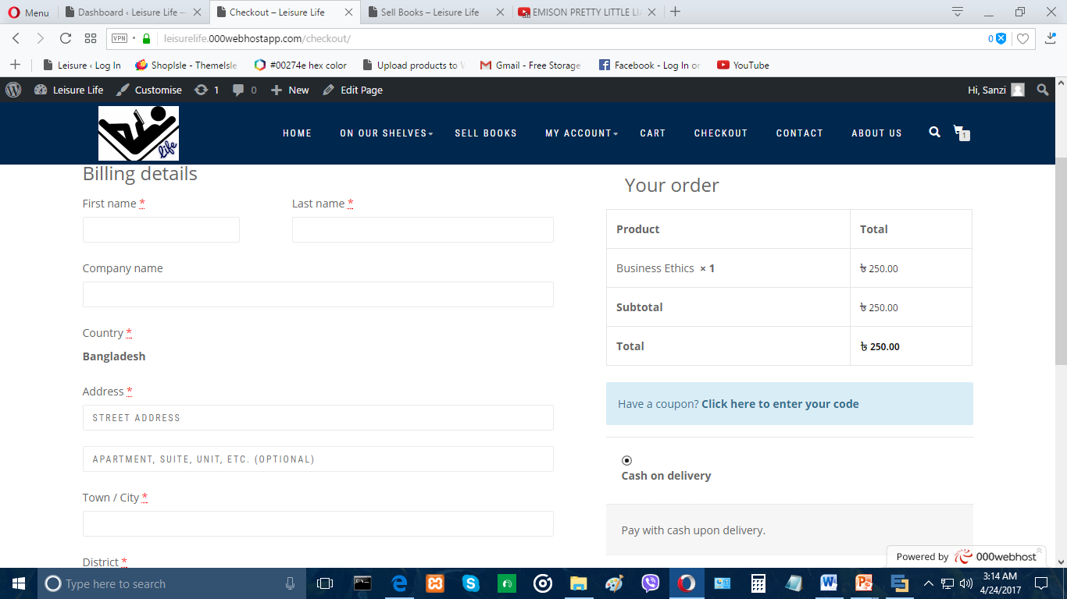

**Conclusion**

**Conclusion :**

As we are offering Books at a cheaper price we tend to get more customers who would like to buy from us. It’s a user friendly website so anyone can buy from us. Thinking from the user perspective we tried to keep the website simple , interactive and beneficial. We are still working in the development of the project. And we will improvise it more in near future. Over all we tried to create a project that can ease many user’s specially many student’s problem. And we think that we have succeed in our first attempt.

**Future Directions :**

* We are planning to add in an online live chat option as well as a comment section, where users can interact with one another and ask any questions or queries.
* We are planning to make this website more creative ,impressive and user interactive by adding more graphics, i.e. in short we will be making it more user friendly and attractive.
* More categories of books will be added.
* We are planning to sell stationeries or accessories alongside books as well for more effective learning experience.

**References :**

* https://www.rokomari.com/book
* http://www.uofastore.com
* https://www.brown.edu/campus-life/support/bookstore/featured-recommended
* http://www.harvard.com/shelves/used_books/
* http://www.uwbookstore.com/home.aspx
* http://papertree.com.bd/cart/